**Overview**

Using .NET MVC (or above) and SQL Server Express create a single page application. The application will allow users to create contacts and add address information to the contact. The application will also allow users to view address information of multiple addresses on a single Google map.

**User Interface Requirements**

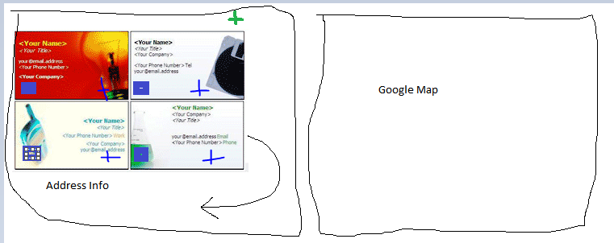

* The main application will run on a single page. The page must only load once. Any subsequent requests must be done via AJAX.
* You can use any UI framework of you choice like i.e. Bootstrap.
* The use of tables is not allowed to style the layout.
* The page will have two sections. The left will show all contacts in a card view style (similar to Outlook).
  + The address cards will show the contact information as well as the address information.
  + The cards also need a checkbox which will be used to select which addresses are displayed on the Google map.
  + The green plus sign above the cards will allow you to create a user.
    - When clicked a modal window is displayed containing a form to create a user and address.
    - All data must be validated using your validation library of choice.
  + The blue plus sign will allow a user to add an address.
  + As a user creates users the cards must flow under each other like the picture.
* The right will have a Google map (show default/empty map on initial load).
  + When a user selects an address by checking the check box, the map will update.
  + The address is removed if the user unchecks the check box.
  + The user must be allowed to select multiple addresses.
  + When the address is selected the card is highlighted yellow.
* The web page must use CSS to display the information in a cleanly formatted way.

**Functional Requirements**

* After the initial page load, only JSON is allowed to be passed to the client. Absolutely no HTML.
* Use Angular as the client-side JavaScript library
* The application must only do the following:
  + Add user
  + Add address
  + Delete user
    - When a user is deleted, it must be deleted from the DB and from the UI.
* You main application page must be a simple HTML page not a Web Form. For any other content you can use whatever is necessary.

**Database Table Requirements**

All the information must be stored in a SQL Server Express database. This database must reside in the App_Data folder.

**Code Requirements**

Your code must get the data from the database and populate strongly typed objectsthat represent the Contact.

You can use any data access technology. Do not use SQL Data Readers.

You must apply standard n-layer design. Create a design where:

* Your UI is not directly tied to your data layer.
* Your Business logic is separate from your data layer.
* Your data layer uses the Repository pattern.
* Direct queries on the table in the data layer are not allowed.

Application errors must be handled in a clean way and a history of the errors must be kept using your choice of methods. Unhandled application errors must not be shown to the user. You must show friendly messages.

**Delivery**

Send all files for your solution as a zipped file, the Database as a script (using the generate scripts option of the SQL server) and upload all here: <https://files.aksia.com/ul/83eHIbifj8> . Everything required to run the application must be included.